**REMOTE LABS FOR LIFELONG LEARNING: ENGAGING STUDENTS WITH ACTIVE LEARNING PEDAGOGY**

NaguNaganandhini

School of Engineering, Temasek Polytechnic, Singapore

Naganandhini_NAGU@tp.edu.sg

**Abstract**

**COVID-19 pandemic has brought uncertainty in educational responses, skilling methods and training practices across institutions. Remote Lab, which provides online interfaces to physical labs, allows students to conduct experiments with real-world equipment anywhere, anytime. Furthermore, the interactive e-Learning package helps institutions guarantee the continuity of students’ learning processes, regardless the obstacles faced.  Therefore, Remote Lab and e-Learning packages were integrated as teaching platforms to seamlessly achieve the learning objectives. Given the pandemic’s multiple restrictions on lab hours - a significant hindrance to students’ learning - these platforms are especially useful. This paper summarises the approach and outcomes of Remote Lab and the implementation of an interactive e-Learning package for a lab-based Industrial IoT Analytics module. Moreover, it outlines the rationale for implementing Remote Lab, with the goals of lifelong learning and employing active learning pedagogical framework. It shares a full instructional strategy, demonstrating how high-effect teaching methods, calibrated to cognitive scientific principles, were combined with appropriate educational technology tools to create effective learning experiences.**

**The 2020–2021 academic year was unique for educators, who adapted to conduct courses remotely. Due to strict protocols, students returned home immediately after lessons. To prevent students’ learning from being unduly compromised, the author set-up a Remote Lab, developed an engaging, interactive e-Learning package with formative assessments, and implemented them. Despite the shift back to face-to-face teaching post-COVID-19, the online resources remain accessible by Pre-Employment Training (PET) and Continuing Education and Training (CET) students in the Learning Management System (LMS). Remote Lab provided students with real-time, industrial hands-on experience to access shop floor machines in the SMART industry platform virtually. Allowing CET students to access these resources promotes lifelong learning and continual upskilling to meet current industrial needs, thereby broadening career prospects. This also promotes inclusivity, as all students can virtually access resources remotely. The resources are well-received by students, primarily because the Remote Lab is more accessible, and students can rewatch the e-Learning modules multiple times, hence facilitating self-directed learning. Based on the findings, both resources are recommended to be adopted post-pandemic, to aid students’ lifelong and active learning, long-term knowledge retention and upskilling.**

**Keywords:** *remote lab, active, lifelong, interactive, e-Learning*

**Introduction**

Polytechnics in Singapore are tertiary institutions that adopt a Practice-based and Skills Education (PSE) framework to prepare learners for and upskill learners in the working world, alongside aiming to nurture graduates to be lifelong learners. The emphasis within polytechnic education is geared towards preparing PET students to be ready for the workforce, and guiding CET students to upskill, keep abreast of emerging demands and thereby stay relevant in the new economy. Education statistics digest (2022) reports that around 46% of students from post-secondary education enrol into polytechnic, a significant proportion of individuals.

In Temasek Polytechnic, Industrial Internet of Things Analytics is offered as an elective module to four PET diploma courses in the third year of students’ polytechnic diploma study, and as a core module to two CET diploma courses in the second year of their polytechnic diploma study in the School of Engineering. Due to COVID-19, which led to the institution of strict protocols and restricted stay on campus, the teaching team adopted a Remote Lab integrated with an interactive e-Learning package to ensure that students could have an unduly compromised learning experience. After the shift back to face-to-face teaching post-COVID-19, both resources were made available round the clock. This facilitated and fulfilled interested students’ intellectual curiosity, as they could continue to access the machines remotely and learn at their own pace, fostering long-term skill retention. The increased accessibility of resources also created a more inclusive learning environment, as disabled students, or students who, for other reasons, must take courses remotely could continue learning (Colwell, Scanton, & Cooper, 2022; Scanlon, Colwell, Cooper, & Di Paolo, 2004). The pilot phase of the Remote Lab with e-Learning package was started at the end of April 2021 semester and has had three consecutive runs. This is a step towards ‘student-centric’ pedagogy, where the student takes control of their learning pace and therefore develops lifelong learning skills. In line with this, the pilot run was found to promote one-to-one technology-enhanced learning, which enabled “seamless learning spaces”, active learning, increased students’ engagement, long-term retention, lifelong learning and upskilling to meet current industrial needs. Bhute et al., 2021; Zubia & Alves, 2011 reports that Remote Labs provide online interfaces for physical labs. In traditional practical lessons, the facilitator explains the objective of the lesson and introduces the shop floor machines and software needed for the experiment. Additionally, the facilitator shows the experimental setup and explains the procedure to connect, extract and analyse the sensor data using suitable software. After the experiment has been completed, the results of the experiment have to be validated by the lab facilitator. As students need to return home immediately after lab lessons during COVID-19, apart from verbal explanations and demonstrations, students are also given access to Remote Lab, integrated with e-Learning modules, to practise at their own pace for long-term retention. Access to the e-Learning module is given in LMS at the beginning of the semester, which has details of the experiment, equipment needed, experimental set-up and the procedure to complete the experiment. The Remote Lab can be accessed by students for experimentation through a web-based interface. Research shows that students’ learning outcomes in Remote Labs are equal or better compared to physical labs (Brinson, 2015; Corter et al., 2011; heradio et al., 2016; Post et al., 2019). Felder, R.M., & Silverman, L.K. (1988) divide learners into five major groups based on their learning preferences. Figure 1 shows the suitability of Remote Lab integrated with an interactive e-Learning module for learners with different learning styles.

Figure 1: Learning Styles

Active learning is built on formative assessment with reflection, feedback, and support, rather than on summative assessment (Cattaneo, 2017). Formative assessment is therefore incorporated in the e-Learning module and their performance is captured in LMS for teachers, as feedback on students' learning.

In this paper, the author discusses the use of the Remote Lab integrated with interactive e-Learning modules for facilitating practical sessions that helps students retain information and upskill themselves. The author will also discuss the development of the learning resources, feedback gathered, and impact of the resources on students’ performance.

**Subject Delivery**

A lab-based practical approach was used in a third year, first semester elective subject called Industrial IoT Analytics. Students were enrolled for this subject in a 16-week semester. This subject covers essential concepts, the application of industrial software platforms to wirelessly interconnect sensors and the development of dashboards for acquiring, analysing and displaying data commonly found in Industry 4.0 digital transformation. Students were split into small groups of 25 and were scheduled for 4-hour weekly lab sessions. Students were expected to do a pre-reading of the lab sheets uploaded in the LMS and come prepared for the practical lesson. During the practical lesson, under the guidance of a lab facilitator, students will follow the instructions in the lab sheets and complete the lab procedures. At the end of each topic, the facilitator played a Kahoot game to recap the lesson content. Using apps and games for learning assessment create an engaging, interactive learning environment, driven by healthy competition. This is a powerful new strategy to influence and motivate groups of people, including students. (Gamification. 2013). In summary, the practical lesson plan was designed with appropriate teaching activities and was delivered using suitable teaching tools to effectively facilitate student learning. After gathering students’ feedback, the teaching activities and the application of the teaching tools were reviewed, adapted and modified to suit their learning needs.

**Remote Lab integrated with an interactive e-Learning module**

Industrial IoT Analytics is one of the modules offered to PET and CET students, where students typically have no prior hands-on experience in handling Industrial 4.0 use cases and the relevant software. During COVID-19, students needed to conduct experiments with guidance from the lab facilitator, and immediately leave the campus after lessons. The subsequent lack of on-campus practice due to pandemic restrictions led to the development of additional online learning resources, such as Remote Lab–to access shop floor machines virtually–and interactive e-Learning modules with formative assessments–for active learning. As the Remote Lab setup and procedures to access the shop floor machines were new and unfamiliar to students, the e-Learning module actively engaged them with an enhanced guided visual procedure to sustain their interest and attention. The implementation of these appropriate learning resources helped students gain more hands-on practice. A major advantage of Remote Lab, unlike traditional learning methods, is that the former is far more accessible. Moreover, the Remote Lab not only challenged students intellectually, but also did so in an engaging, easily comprehensible manner. Another advantage of Remote Lab is that students are expected and required to display self-regulation by planning and executing experiments them­selves (Daradoumis, Marques Puig, Arguedas, Calvet Linan, 2021; cf., Litzinger, lat­tuca, Hadgraft, Newsletter, 2011). Nonetheless, conducting Remote Lab experiments online comes at the cost of teachers and peers being physically present to encourage, motivate and support them during experiments. However, the e-Learning module makes up for the lack of teachers. As students have hands-on experience once in the lab, guided by lab facilitators, additional resources and facilities help them to continue learning outside the lab at their own pace. It also promotes lifelong learning and upskills CET students. The students, who could access the additional resources post-Covid-19, mentioned benefitting from the resources in the ways detailed above.

**Development of the e-Learning module and Remote Lab**

Students who use both synchronous and asynchronous methods are achieving better grades in contrast to a traditional learning style (Alzahrani, 2019). Current LMS support the usage of completely encapsulated online courses and assessments, using vehicles like the SCORM standard. Hence, all the experiments with audio guided visual procedure are integrated with interactivity and formative assessments using articulate 360. It is developed as a SCORM package and made available to students in the LMS platform. This pedagogy offers a unique sense of presence of teachers and interactivity which are not achieved with the other traditional methods. Students used these additional resources to practise and attempt formative assessments for the preparation of continual assessments and projects. LMS provides a system training platform that holds e-Learning classes to track course completion and assessment scores (Jung & Huh, 2019; Watson & Watson, 2012). Hence, tutors are able to track students’ practice sessions using Learning Analytics, which helps to identify, monitor, intervene and aid low attainers.

Figure 2 shows the development cycle of the interactive e-Learning SCORM package for active learning pedagogy.

Figure 2: Development Cycle

Figure 3 shows the tracking of students’ practice sessions using LMS platform and their performance in the formative assessment.

Figure 3: Learning Analytics

To access the shop floor machines from anywhere and at any time due to COVID-19 restrictions, it was decided that Remote Lab would be developed to support the students to practise the procedures. A Remote Lab includes a physical experiment set-up, a user tracking system, a reposi­tory of information for students and staff, and a user-interface. The Remote Lab used in this study was designed to be scalable in the number of physical set-ups, students and courses, and was allowed for individual assignments. The Remote Lab could be accessed by students for experimentation through a web-based interface. Students could reserve time slots on a 24/7 basis. Figure 4 shows the Remote Lab set-up of the shop floor machines and students’ access to it.

Figure 4: Remote Lab Set-up

**Scenario 1: Face-to-Face Lab**

During the COVID-19 pandemic, both PET and CET students needed to conduct experiments, but were required to leave the campus immediately after lessons. Hence, they lacked sufficient practice for their continual assessments and projects. To be better prepared for such situations, a scenario in Remote Lab, with interactive e-Learning SCORM package for active learning, was introduced. Students were expected to do a pre-reading of the lab sheets available in LMS, watch the e-Learning modules and complete the formative assessment to review their understanding of the concepts and procedures. During the face-to-face lab session, students applied their knowledge, and conducted the experiments in the presence of lab facilitators.

**Scenario 2: Remote Lab**

Students became familiarised with the hardware set-up during the face-to-face lab sessions. To receive more practice, students are allowed to access the shop floor machines from anywhere, at any time. They can also conduct the experiment by watching the e-Learning modules, which have audio and visual step-by-step guidance and explanations recorded. They can rewatch them if necessary, at their own pace, to improve their understanding. CET students and students from the workforce are given access to Remote Lab and LMS platform for the whole semester to upskill themselves progressively, which contributes to their lifelong learning. During post-COVID-19, the teaching team enabled students to continue accessing the Remote Lab and e-Learning module in the LMS platform to view and practise at their own convenience. Figure 5 shows the real time data acquisition of the sensors in the shop floor

machine via Remote Lab.

Figure 5: Real time data acquisition

Figure 6 shows the real time monitoring of the sensors’ data in the shop floor machine via Remote Lab.

Figure 6: Real time data monitoring

Figure 7 shows the SCORM package for guided audio and visual procedure of the Remote Lab with formative assessment.

Figure 7: SCORM package

Figure 8 shows the formative assessment, which was integrated with audio visual procedure using Articulate 360 and subsequently developed as SCORM package.

Figure 8: Formative Assessment

**Results and Discussion**

Remote Lab with e-Learning modules was made available to students from term 2 of the April 2021 semester, and since then, more than 300 students have been given access to these resources. Due to the guided and interactive nature of these online modules, students were motivated to incorporate these resources into their learning, reviews and reflections. Furthermore, students used these resources for pre-practical readings, ensuring that they were well-prepared for the actual session. The resource, which has audio and visual guidance, also served as a very useful tool for students to repeat the Remote Lab experiments, review the lab procedures independently by rewatching them, revise for their projects and practise prior to their practical test. During the practical session, students were expected to complete the tasks, as stated in the lab sheet, and the lab tutor then checked their results and provided relevant, individualised feedback. Lab participation marks were awarded to students based on:

1. Efforts: Manages time well; well prepared before lessons and complies with all lab rules

2. Skills: Demonstrates excellent lab skills, shows great confidence in using software and hardware

Students’ lab participation performance before and after the introduction of the e-Lab SCORM package was studied. Based on tutors’ observation, the percentage of students with poor performance who raised their hands for help during practical lessons had dropped in the April 2022 semester. This meant that more students were better prepared for the sessions. Evidently, besides in-person guidance offered by the lab facilitator, the Remote Lab with cloud version software and SCORM package, both aided slower learners, as well as high achievers, to better understand the lab procedures, complete them at their own pace and review again. It promoted independent, active and lifelong learning amongst students.

Two practical tests are conducted at a regular interval to assess students’ practical skills. For the April 2021 semester, the online resources were made available for reference while doing the project. A comparison of students’ performance in the practical test over the two years (April 2021 and April 2022) was carried out. After the introduction of the Remote Lab and SCORM package, there was a significant drop in the percentage of failures for the practical test. This illustrates that students were able to better learn, retain and apply their knowledge during the practical test. Hence, there was also a significant increase in the average marks of students after the introduction of online learning resources in the April 2022 semester.

As part of the subject review, a survey was conducted to gather feedback on the subject delivery, which included the rolling-out of Remote Lab and SCORM package. Separate surveys with the same questions were released to PET and CET students. Figures 9 and 10 show the bar chart for the PET and CET students’ response corresponding to the survey results.

Q1: I preferred the remote-access lab experiment to the in-person lab experiment.

Q2: I was able to do at my own pace and repeat procedures that I did not understand.

Q3: Performing Remote Access Lab helped me to develop practical hands-on skills at my own pace.

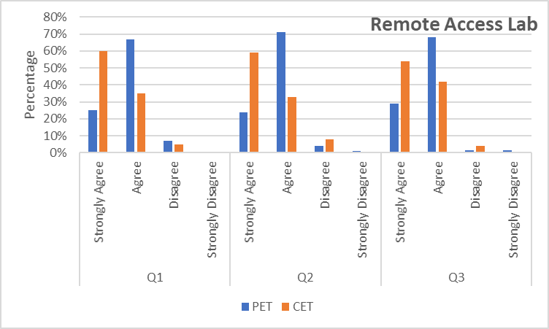

Figure 9: Survey results

From the survey results, a majority of students preferred the Remote Access Lab to the in-person lab and felt positively about being able to do the Remote Lab and repeat the procedures at their own pace. It helped to develop hands-on skills and subsequently complete the experiment. This shows that active, lifelong learning has effectively taken place among and benefitted students.

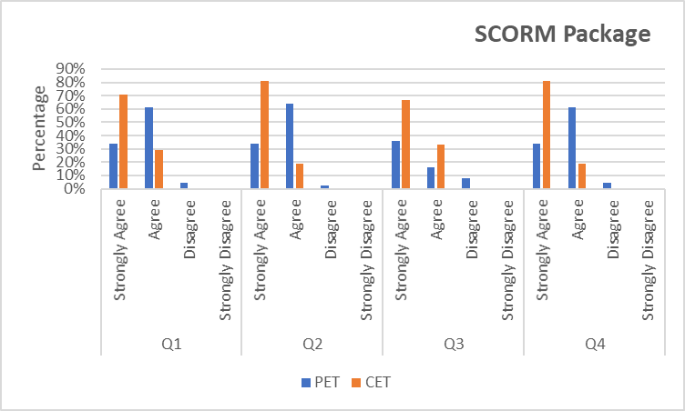Figure 10: Survey results

Q1: The e-Lab video gave me more confidence in my ability to do labs.

Q2: I was able to learn at do at my own pace and review portions that I did not understand.

Q3: The e-Lab video is engaging.

Q4: The quizzes at the end of each e-Lab video helped me to check the understanding of the concepts.

From the survey results, a majority of students felt more confident in their ability to do the labs and felt positively about being able to review the labs and rewatch it at their own pace. Moreover, most found the resource engaging and agreed that it helped to assess their understanding of the concepts. This shows that the interactive resource was well-received by the students, promoted long-term knowledge retention, self-directed learning and deepened the students’ understanding.

**Conclusion**

Remote Lab integrated with an interactive SCORM package was developed and made available to all PET and CET students in the cohort, both during and after the Covid-19 pandemic. The effectiveness of these resources in enhancing students’ learning was studied by analysing students’ feedback, which was gathered from student satisfaction surveys. Due to the convenience, interactivity, and step-by-step visual and audio guidance in the resources, students felt incentivised to utilise them while learning. Furthermore, students actively engaged themselves during the experiment because of the variation in the guidance procedure offered. Almost all students agreed that the resources had helped them understand the experimental procedures, retain their knowledge, and cultivate the habits of active, lifelong learning and upskilling.  They also felt that they had gained sufficient practice to perform well for their assessments and projects. The drop in percentage of failures in both the practical test and lab participation illustrates that both resources have helped low attainers learn more effectively and apply their knowledge to excel in assessments. In summary, the access to Remote Lab and e-lab SCORM package post-COVID-19 have resulted in the following notable benefits:

1.  Promoting active learning amongst students via e-lab SCORM package

2. Facilitating efficient learning, via interactions with and access to the shop floor machines

3.  Upskilling for CET students

4.  Lifelong learning for CET students

5.  A student-centric approach, which encourages self-directed learning

6.  Building a learning environment inclusive of learners’ different styles, via a variety of available resources

In conclusion, the implementation of Remote Lab with interactive SCORM package post-COVID-19, especially for subjects requiring expensive equipment, was a success. It was effective in enhancing students’ active learning, evidenced from students’ improved performance in assessments and overall positive feedback.

**Acknowledgements**

The author would like to thank Diploma in Computer Engineering, Temasek Polytechnic, for providing access to the facilities to set-up the Remote Lab, the Engineering Academic Administration Team for giving access to the recording studio facilities, and the students from Diploma in Business, Diploma in Electronics, Diploma in Information Technology and Diploma in Mechatronics for delivering SCORM package under the Multidisciplinary Internship Learning Programme.

**References**

Broisin, J., Venant, R., & Vidal, P. (2017). Lab4CE: a remote laboratory for computer education. *International Journal of Artificial Intelligence in Education*, *27*, 154-180.

Cattaneo, K. H. (2017). Telling active learning pedagogies apart: From theory to practice. *Journal of New Approaches in Educational Research (NAER Journal)*, *6*(2), 144-152.

Corter, J. E., Esche, S. K., Chassapis, C., Ma, J., & Nickerson, J. V. (2011). Process and learning outcomes from remotely-operated, simulated, and hands-on student laboratories. *Computers & Education*, *57*(3), 2054-2067.

Felder, R. M., & Silverman, L. K. (1988). Learning and teaching styles in engineering education. *Engineering education,* 78(7), (pp 674–681).

Gallagher, S. E., & Savage, T. (2020). Challenge-based learning in higher education: an exploratory literature review. *Teaching in Higher Education*, 1-23.

Ginsburg, M. (2010). Improving educational quality through active-learning pedagogies: A comparison of five case studies. *Educational Research*, *1*(3), 62-74.

Gustavsson, I., Nilsson, K., Zackrisson, J., Garcia-Zubia, J., Hernandez-Jayo, U., Nafalski, A., & Hakansson, L. (2009). On objectives of instructional laboratories, individual assessment, and use of collaborative remote laboratories. *IEEE Transactions on learning technologies*, *2*(4), 263-274.

Hernández-de-Menéndez, M., Vallejo Guevara, A., Tudón Martínez, J. C., Hernández Alcántara, D., & Morales-Menendez, R. (2019). Active learning in engineering education. A review of fundamentals, best practices and experiences. *International Journal on Interactive Design and Manufacturing (IJIDeM)*, *13*, 909-922.