**LEARNING INVIGORATED: USING MICROLEARNING**

**AS A TEACHING METHODOLOGY**

Tan Hwee Yong

Republic Polytechnic/School of Infocomm, Singapore

tan_hwee_yong@rp.edu.sg

**Abstract**

**Republic Polytechnic (RP) adopts a learner-centred approach, acknowledging student voice as central to the learning experience by employing instructional strategies, such as problem-based learning, project-based learning, interactive seminars and cognitive apprenticeship. With technology revamping the way humans live, communicate and conduct business, e-learning is increasingly used as a mode of lesson delivery in the campus. Together with the other learner-centred instructional strategies, Microlearning (ML) which is an instructional design that delivers information in a smaller and easier-to-digest format, has the potential to be weaved into the curriculum to achieve the desired learning outcomes.**

**In this study, a conceptual framework is developed to implement microlearning in the curriculum at Republic Polytechnic for learner-centred environment.** **The framework covers:**

* **What is microlearning?**
* **Why should microlearning be implemented in the curriculum?**
* **What are the key features of microlearning?**
* **How to implement microlearning?**

**This study assesses the effectiveness of the proposed framework for microlearning implementation in RP aligned to the institution’s needs. It looks at how microlearning can be used to deliver content and complement traditional teaching and learning, reinvigorating students’ love for learning.**

**Four SCORM packages were implemented in a lesson to gain useful insights into the learner's reaction and learning through microlearning. The results, derived from Focus group discussions (FGDs), indicated that the learners considered short duration of the microlearning courses helped enhance comprehension, enabled accessibility and increased interactivity.**

**Keywords:** *e-learning, microlearning, bite-sized learning, anytime, anywhere, learner-centred.*

# Introduction

Microlearning, as its name suggests, is most often referred to as bite-sized learning or training. However, there are many definitions of microlearning and in reality, it goes beyond just delivering information in a shorter duration. It is increasingly perceived as a modern trend in learning that allows learners to learn anytime, anywhere. It has also evolved as an instructional design to support learning in the VUCA (volatility, uncertainty, complexity, and ambiguity) world whereby average attention span of people has decreased over the years, and the dynamics of constant information overload makes it difficult for them to absorb and retain the knowledge (Bastow, 2022).

Despite the fact that microlearning is yet to be described in detail (in research studies, methodologies and textbooks), it is increasingly used as a means of teaching due to its unique cutting-edge approach in benefiting learners of all ages. There are diverse explanations to prove why microlearning works, such as processing bite-sized bits of the content may increase information retention by 20% (Giurgiu, 2017), as it reduces cognitive load (Hogle, n.d.). In most cases, microlearning delivery leverages on technology and is made available on any smartphone, tablet, or portable computing device. This brings benefit in the aspect of accessibility. On top of that, microlearning has been found to increase learners’ conceptual understanding and act as a stimulus for intrapersonal growth. It also boosts learner’s self-expression and provides more meaningful opportunities for social interaction among learners (Brebera, 2017).

In order to use microlearning instructional design, educators will need to comprehend what is microlearning, the purpose of using microlearning, the key elements that constitute microlearning and how microlearning can be designed and weaved into the curriculum to meet its intended purpose. The development of the microlearning conceptual framework incorporates the above-listed attributes and aims to help educators identify and deliver suitable learning content using microlearning. In addition, the implementation of microlearning will enhance the learning experience of the learners.

In this study, a common issue among learners was identified: difficulty in retaining information. Existing literature in the field of microlearning was studied to assess its use to develop a conceptual framework for RP.

The framework was then outlined in a guide as a means to provide an overview of microlearning as well as how to design a microlearning lesson in RP’s context to all teaching staff.

To evaluate the effectiveness of the framework, a lesson design for the module on critical thinking and problem-solving skills, which comprises four microlearning courses for preliminary data collection, was implemented. Qualitative feedback data was collected from learners to

address the following research question (RQ)s:

RQ 1: Does the microlearning framework aid learners’ learning?

RQ 2: How do learners perceive their learning using microlearning courses?

**Basis of Microlearning**

Hermann Ebbinghaus, a German psychologist, noted that memory does not stay consistent. Depending on the subject matter and the methods of learning, memory power can increase, decrease, increase, decrease, in an ongoing cycle. As depicted in the Forgetting Curve (Figure 1) which he discovered in 1885, **80% of the knowledge** learnt is lost within one month.

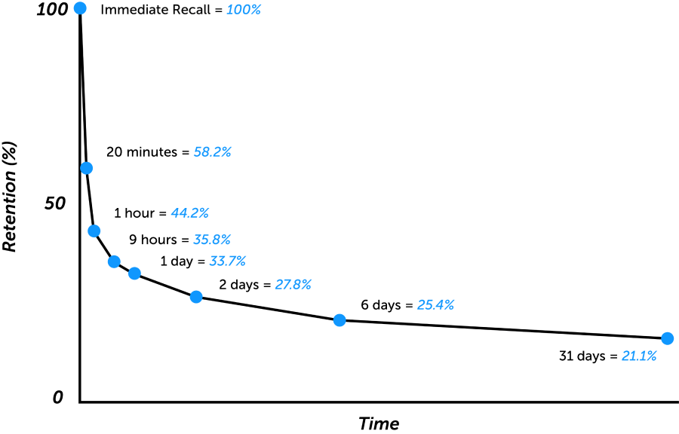

Figure 1: Ebbinghaus Forgetting Curve graph

At the same time, Ebbinghaus also discovered the method of **Savings** which refers to knowledge once held at the top of the mind, in its entirety or near to complete accuracy, as well as the retention of the information thereafter. Frequently revisited information can be recalled much easier even after a significant time of not using it.

When learning large amount of information all at once, it is virtually impossible for learners to retain all information. Certain information will be retained in learners’ short-term memory but the knowledge will degrade over time if not repeated and reinforced.

The microlearning concept of splitting the content into bite-sized pieces and recalling different parts of it throughout a spaced interval can help improve knowledge retention and productivity.

In the Ebbinghaus’ memory retention graph (Figure 2), it can be seen that when one learns something new, all the information will be retained. However, as time goes by, memory retention starts to drop. But then again, if the information is continuously reviewed, the retention of it increases.

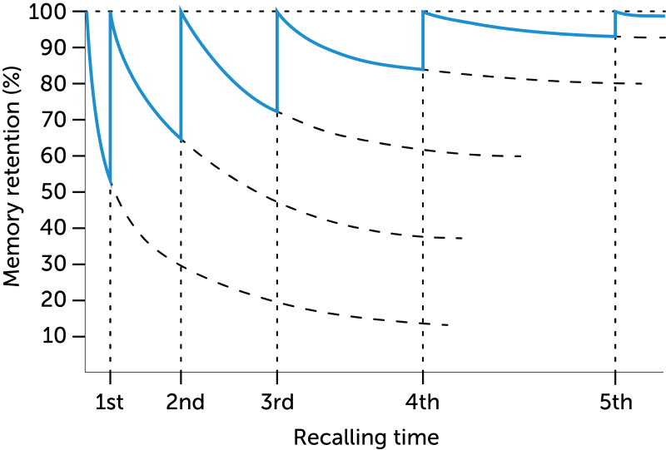

Figure 2: Ebbinghaus Memory Retention graph

However, these are some ways to beat the forgetting curve and ensure that knowledge is retained (JoyForm by JoyfulPerson, 2022):

* **Spaced learning.** According to Ebbinghaus, knowledge can be easily retained if divided into chunks and repeated over measured intervals.
* **Just-in-time learning.** For important tasks or tasks that are not performed frequently, provide learners support at their point of need with microlearning, helping learners put the knowledge acquired into practice.
* **Micro assessments.** Encourage learners to review and test their acquired knowledge at regular intervals so that the information is embedded into their memory.

This paper seeks to develop a framework to look at how information can be shared and received, amid the shrinking human attention span. Despite being constantly flooded with information, it cannot be denied that people now have the ability and luxury to be highly selective about the information consumed and absorbed. Thus, it is more than ever crucial to change the way information is delivered (to capture people’s attention) (JoyForm by JoyfulPerson, 2022b).

**Why Microlearning?**

There are various key factors attributing to why microlearning courses are more efficient than traditional ones with longer duration, as depicted in the following (Qualee Technology, 2022):

* **Fast impact.** Learners tend to understand a topic faster when presented with concise and focused information. In addition, microlearning lowers the threshold to start a new topic.
* **Increased freedom.** As microlearning lessons are usually presented on an accessible digital platform with manageable chunks of information, learners can learn at their own pace and convenience.
* **Elevated engaging experience.** Learners perceive microlearning to be engaging. The experience for learners is similar to browsing their favourite social media app, as opposed to the "serious study" feel of a regular classroom setting.
* **Improved knowledge retention.** When a subject is studied repeatedly and can be easily revisited, knowledge retention is higher. When information is concise, it also prevents cognitive overload.

By applying this to RP’s context, microlearning is a teaching and learning method that:

* serves to bridge a just-in-time knowledge or skill-based gap
* is accessible through a digital platform that allows learners to learn anytime, anywhere
* consists of self-contained, bite-sized learning activities that last no more than 15 minutes

**Proposed Conceptual Framework for Microlearning**

The proposed conceptual framework for microlearning comprises the elements depicted in Figure 3.

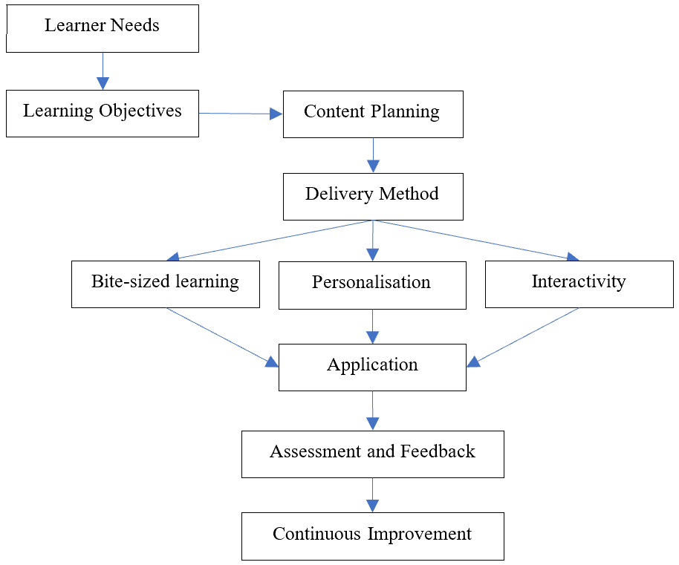

Figure 3: Conceptual Framework for Microlearning

* **Learner Needs.** Learners’ needs and preferences guide the design of microlearning courses. Understanding learner's goals, interests, and prior knowledge is important for creating effective microlearning content.
* **Learning Objectives.** The specific knowledge and skills that learners are expected to acquire through the microlearning experience should be measurable and aligned with the lesson’s overall learning objectives.
* **Content Planning.** Consists of ***content strategy*** that defines the topics and skills that will be covered in the microlearning course, as well as ***content design***, which is the process of creating and organising the actual content.
* **Delivery Method.** Microlearning courses can be delivered through a variety of methods, such as video, audio, text, or interactive simulations. The delivery method should be selected based on the learner's needs and the content planning.
* **Bite-sized Learning.** Microlearning course is delivered in bite-sized units that can be easily consumed in less than 15 minutes. Each course focuses on a single concept or skill and is designed to promote deep understanding and retention.
* **Personalisation.** The microlearning content should be tailored to meet the learner's needs and preferences, such as being able to learn anytime, anywhere.
* **Interactivity.** The microlearning course should be designed to encourage active participation and engagement, such as through quizzes, games, social media or other interactive activities.
* **Assessment and Feedback.** Assessment and feedback help to ensure that learners acquire the desired knowledge and skills. Assessments should be aligned with the learning objectives and provide learners with meaningful feedback on their progress.
* **Application.** Microlearning courses should be designed to allow learners to apply their new knowledge and skills in real-world situations. It can be facilitated through application and practice, such as case studies or simulations.
* **Continuous Improvement.** Continuous improvement is important to help ensure the effectiveness of the microlearning courses over time. Feedback from learners and assessments should be used to refine and improve the content and delivery of the microlearning courses.

**How to design Microlearning?**

In designing microlearning for RP’s context, a simple 3-step method was introduced to guide staff in their development of microlearning courses.

***Step 1: Design***

* Identify a suitable learning outcome
* Determine duration, maximum 15 minutes

These questions may be asked when identifying a suitable learning outcome:

* Is this learning outcome specific (e.g., focus on a single topic/problem/context)?
* Is this learning outcome measurable?
* Is this learning outcome achievable within 15 minutes?
* Is this learning outcome realistic (e.g., does it require the use of complex equipment or software)?
* Is this learning outcome timely (i.e., just-in-time to bridge a specific knowledge or skill gap for the learners)?
* Is this learning outcome stand-alone (i.e., it can be learnt independently)?

***Step 2: Develop***

* Follow the I-D-C (Introduction-Development- Consolidation) cycle

**Introduction**: Gain attention & share learning outcome

* Share Quote
* Present a Question
* Present a Scenario
* Tell a Story

**Development**: Present information

* Weblink/Text/Document (max 500 words)
* Video/Audio (max 3 minutes)
* Graphics/Infographics
* Interactive games/simulation

**Consolidation**:

* Test for Understanding (TFU)
* Mind-maps, Games, Simulations
* Puzzles/Matching
* Multiple Choice/Fill-in-the-blanks, etc.
* Provide Feedback
* Model answers
* Real-life Application
* Areas of improvement
* Facilitates collaboration/discussion (optional)
  + Padlet, Forums

***Step 3: Deliver***

* Identify suitable digital platform to deliver, e.g.
* iSpring Marketplace
* RP’s online learning platform (iSpring, Articulate Rise, PPT), etc.

**Implementing Microlearning**

To validate the workability of the derived framework and test its effectiveness, four microlearning courses, not exceeding 15 minutes each, in the form of SCORM (Sharable Content Object Reference Model) packages, were implemented in a lesson of a module in RP. Refer to Appendix A for the lesson plan of the microlearning courses.

The microlearning courses, were developed using Articulate Rise, a readily available authoring tool. Each course focuses on one learning outcome, using a variety of supplementary media content such as videos and quizzes to enhance knowledge acquisition.

The microlearning courses were released as pre-readings to the lesson on RP’s online learning platform and learners were able to go through the courses at their own time and at their own pace.

Qualitative analysis is then performed based on the data collected via focus group discussions with the learners.

**Data Analysis Methodology**

The interview data from the FGDs was analysed using the three phases of the Grounded Theory methodology in analysing qualitative data.

Phase one is systematic coding, i.e., breaking down of data according to a code list so as to identify relevant and similar patterns (Open coding). The coded segments are then grouped to form more broader categories (Phase two, Axial coding), which in turn, gets linked to more general themes and theoretical concepts (Phase three, Selective coding) that captures the essence of the research. (Corbin and Strauss, 1990).

**Results and Discussion**

A total of 970 learners attempted the microlearning courses and 27 of them took part in the FGDs, sharing their learning experiences of going through the courses. Refer to Appendix B for the questions used to collect student responses.

The final code system had the following (main) themes to find out if the microlearning approach helps facilitate better learning of the learners:

* Duration
* Comprehension
* Accessibility
* Interactivity

***Duration***

As technology advances, information gets more readily available and accessible, thus leading to shorter focus time, simply because there is no longer the need for the extra time to search for information. With this, the attention span of people gets shorter.

|  |  |
| --- | --- |
| ***Participants Feedback*** | ***Findings*** |
| “My attention span is not that long. I cannot like focused very long.”  “The short SCORMs are fine. the long ones I was doing other things due to having a short attention span.”  “I prefer short, short, SCORM package because if too long right I think I just want to like finish it like because it's too long really. Then I get bored easily. So yeah, so I prefer short one.”  “A culture shock to get really short SCORM packages for critical thinking and I want to appreciate and I prefer shorter SCORM packages than really, really long SCORM packages.”  “Shorter packages give you better retention so that you can ask the questions the next day.” | One of the attributes of microlearning is the short duration of no more than 15 minutes. This fits learners with shorter attention span as they are better able to stay on the screen and complete the courses. This was affirmed by 19 out of the 27 students who participated in the FGDs. |

***Comprehension***

Concentration naturally deteriorates with overloading of information, resulting in lower comprehension and knowledge retention, which links to the effect of the Forgetting Curve.

|  |  |
| --- | --- |
| ***Participants Feedback*** | ***Findings*** |
| “For critical thinking it's more ideal to like break it up into smaller digestible pieces for the students to learn and understand.”  “Short and sweet and concise SCORM package will enable me to learn that specific term for that content or that short section or the content, because to me, jumbling all together, sometimes I have to stop halfway and I forget what I've learned before or I miss out on certain parts to remember others.”  “Since we've already gone through the pre-readings, …, we can apply it to the problem statement and relate.”  “For me, I find the pre-readings very interesting and it's very, not content heavy.”  “At some point I may get lost, but at the same time right at certain parts of the SCORM package, I felt that it was quite concise and clear that the packages were trying to put across their points and so.”  “I was actually not distracted because I find it quite interesting, is like I was able to apply it well in class.”  “The SCORM packages were really that much concise and well-illustrated to the point that there's no need for us to struggle at all.” | Of the 27 students who participated in the FGDs, 18 of them mentioned that the SCORM packages were easy to understand and they were able to better focused on the learning outcomes.  Due to the fact that each microlearning course consists of just one learning outcome, the intent is clearer and learners are able to focus better on the topic, as it is deemed simpler and at times, more interesting. Their understanding, too, can be easily verified. |

***Accessibility***

Accessibility in education helps create equal opportunities for all learners. If learning materials are not accessible to learners, then learners' abilities will not be fully developed.

|  |  |
| --- | --- |
| ***Participants Feedback*** | ***Findings*** |
| “I had to head out for dinner and then even like that, I was able to just complete the SCORM packages, even while I was outside. So, I think they're also like, the short duration of them also makes them like pretty convenient.”  “Even the quizzes. Uh, I would say like, fun to do. We're able to try again to get 100%.”  “Students can read multiple times and then, I mean, the teacher can actually explain them in class too.”  “Sometimes throughout the lessons I still reopen this SCORM packages when I'm in need of the resources.”  “Everybody does the SCORM packages at different times sometimes.”  “When I do those SCORM packages I'm able to like, go at my own pace.”  “I think for me it would be the questions embedded in the learning packages. I can like go and try the questions and then check my understanding and like go back even if I got it wrong, I can go back and check again.” | Microlearning, being offered on a digital platform, is accessible to learners 24/7, allowing them to view the courses at their own convenience, anytime, anywhere. In addition, learners are able to revisit the courses.  Of the 27 students who participated in the FGDs, 9 of them appreciated the convenience brought about by the SCORM packages. |

***Interactivity***

Microlearning is best supported with the use of media which has interactive elements to reinforce learning.

|  |  |
| --- | --- |
| ***Participants Feedback*** | ***Findings*** |
| “I can see, like my classmates’ opinion and like I can like see whether I can, you know, agree with the points or because there was there's like a different perspective on the topic itself.”  “The discussion at the end of each SCORM packages because is a way for us as students to check our understanding and knowledge with between one another and also to clarify our doubts with one another and at the same time our lecturer can ensure that we actually understood the right concepts.”  “When we do the SCORM packages on our own, we understand it differently. And when we get together, we can consolidate our learning and get on the same page.” | Different media can be incorporated into microlearning courses. Leveraging on media has created collaborative opportunities and greatly enhanced interactivity.  Of the 27 students who participated in the FGDs, 12 of them found increased interactivity among learners. |

***Differing Opinions***

Despite the many positive feedback for the four microlearning courses, there are also differing opinions that call for areas of improvement.

Being short and concise, the information presented in the microlearning courses may not be detailed enough. As such, learners who prefer traditional courses with more thorough information found little pleasure when going through the courses.

In addition, some learners commented on the lack of more challenging questions and suggested for more variation of activities.

# Conclusion

From the results of the FGDs, two-thirds of the participants affirmed that the short duration of the microlearning courses aid in their comprehension of the learning objectives.

The microlearning framework was shown to befit RP’s teaching and learning approach, and in general, it was well incorporated into the lessons to complement traditional learning, benefitting the learners and helping them find new confidence and interest for learning.

Whilst there are shortcomings of microlearning, it cannot be denied that the advantages much outweigh the disadvantages.

The proposed microlearning framework in the implemented lesson was one that worked for majority of the learners, and it deserves to be further explored for other courses and schools within RP to further assess the effectiveness of microlearning. More detailed planning of the curriculum and activities as well as meticulous selection of suitable learning outcomes must be carried out to fully realise the potential of microlearning.

**Acknowledgement**

It is a great pleasure to acknowledge Ms Sharon Tan Bee Wah and Ms Urvi Maniar, lecturers of Republic Polytechnic, who worked with me on this research project. They have been great teammates and without them, the study would not have been conducted smoothly.

# References

Bastow, M. (2022, August 26). Decreasing Attention Spans And The Affects On Learning – Jennifer Oaten. Santa Maria College. https://santamaria.wa.edu.au/decreasing-attention-spans-jennifer-oaten/#:~:text=What%20is%20to%20blame%20for,children's%20attention%20spans%20are%20short.

Giurgiu, L. (2017). Microlearning an evolving eLearning trend. Scientific Bulletin, 22(1), 18– 23.

Hogle, P. S. (n.d.). 7 Ways Microlearning Helps You Reduce Cognitive Load. https://www.ottolearn.com/post/119-seven-ways-microlearning-helps-you-reduce-cognitive-load

Javorcik, T., Polasek, R., (2019). Practical Application of Microlearning in Education of Future Teachers,18th European Conference on e-Learning (ECEL 2019) at Copenhagen, Denmark

Anand, T. (2018, February). 11 custom learning trends in 2018: Top trends to look out for in 2018. *Training and Development Excellence Essentials*.

Perry, M. (2017). Learning trend: Microlearning. Canadian Journal of Medical Laboratory Science, 79(2), 7

Brebera.P.(2017). Microlearning in foreign language courses: A threat or a promise? In A. Mesquita & P. Peres (Eds.), *Proceedings of the 16th European Conference on eLearning (pp. 85-93).* Reading, England: Academic Conferences and Publishing.

Brown, G. A. D. (2021, October 20). Microlearning vs Traditional Learning. EdApp Microlearning Blog.

https://www.edapp.com/blog/transitioning-from-traditionalclassroom-

training-to-microlearning/

Brew, M. (2022, February 18). *What is microlearning?: Definition, benefits & examples*. eduMe. Retrieved May 26, 2022, from https://www.edume.com/blog/what-is-microlearning

Valamis. (2022, December 28). *Microlearning*. https://www.valamis.com/hub/microlearning

JoyForm by JoyfulPerson. (2022b, July 29). Why Microlearning is the Antidote to Shrinking Attention Spans. https://www.linkedin.com/pulse/why-microlearning-antidote-shrinking-attention-spans-joyfulperson

JoyForm by JoyfulPerson. (2022, July 14). JoyForm by JoyfulPerson on LinkedIn: #jobs #training #learning #microlearning #learninganddevelopmentâ¦. https://www.linkedin.com/posts/joyfulperson_jobs-training-learning-activity-6953166993432731648-jexT?utm_source=linkedin_share

Qualee Technology. (2022, May 19). *The 7 Benefits of Microlearning*. https://www.qualee.com/blog/the-7-benefits-of-microlearning

**Approval Certificate**

You are required to submit the approval certificate for the purpose of maintaining and publicizing the record of the symposium. The copyright of all contents on your paper is reserved by the author(s) and/or the institution, even if you submit the approval certificate. The sentences on copyright holder(s) and the handling of papers are indicated on every page.

***APPENDIX A***

|  |  |
| --- | --- |
| **Learning Outcomes** | * Recognise characteristics of complex problems * Analyse complex problems using tools such as 5-whys and nested systems * Explain quick fixes and their unintended consequences |
| **Description of the four microlearning courses implemented as pre-reading for the lesson** | **Microlearning course 1 - Applying Nested Systems to a complex problem**  By the end of this microlearning course, learners should be able to use the Nested Systems tool to analyse a complex problem. This course takes about 10 minutes to complete and includes a Practice Quiz.  **Microlearning course 2 - Finding the Root Cause of a Problem**  By the end of this microlearning course, learners should be able to:   * Use the 5-whys method to analyze a problem * Identify the root cause of a problem using the 5-whys method   This course takes about 10 minutes to complete and covers the below:   * Wait, so what's the REAL problem? * How to use the 5-whys method? * What is the root cause of a problem? * Practice Quiz   **Microlearning course 3 -** **Recognising Complex Problems**  By the end of this microlearning course, you should be able to:   * Recognise the characteristics of a complex problem * Appreciate how systems thinking can help us analyse a complex problem   This course takes about 10 minutes to complete and covers:   * What makes a problem complex? * What is systems thinking? * Practice Quiz   **Microlearning course 4 - Solving Complex Problems**  By the end of this microlearning course, you should be able to propose long-term solution(s) that address a complex problem. This course takes about 10 minutes to complete and covers:   * Long term vs short term solutions * Unintended consequences * Practice Quiz |

***APPENDIX B***

# Research Purpose:

Develop a conceptual framework of Microlearning (ML) for Republic Polytechnic’s learner-centred environments.

# Research Objective:

To develop a conceptual framework for ML at Republic Polytechnic that covers:

* What is Microlearning?
* Why should Microlearning be implemented in the curriculum?
* What are the key features of Microlearning?
* How to implement Microlearning?

# Purpose of Focus Group Discussions (FGDs):

* Gathering feedback from students for ML SCORM packages implemented in a lesson of a module on critical thinking and problem-solving skills in AY2022 Semester 2.
* Gain useful insights into the learner's reaction and learning through ML SCORM packages implemented

# Research Questions:

FGDs are to gain insights into the research questions listed below. The discussions should be based on the 4 ML SCORM packages implemented.

* How do the students experience the Microlearning SCORM packages?
* How do the students learn through the Microlearning SCORM packages?

# Number of Student FGDs: Five, 3 to 7 students in each group

# Questions for Student FGDs: Objective of the FGDs is to get the answers to the “why” and “how” microlearning course have helped them understanding the lesson.

|  |  |
| --- | --- |
| **Category** | **Questions** |
| Learning Outcomes | * How was the learning experience for you when going through the SCORM packages for lesson 5? * Did the SCORM packages meet your learning needs at that point in time? Explain. |
| Micro-SCORM materials | * What did you find different between lesson 5 SCORM packages and usual SCORM packages? * In your opinion, what type of activities do you prefer for pre-readings? |
| Relevance | * Were you able to relate the SCORM package to each of the learning outcomes? Why or why not? |
| Knowledge/skills acquisition | * Do you feel the SCORM packages equipped you with the knowledge needed to achieve the learning outcomes for the lessons? Explain. * How did you find the duration of the SCORM packages? |
| Collaboration | * Explain whether the SCORM packages give you the opportunity to collaborate** with your peers. * Explain whether the SCORM packages give you the opportunity to collaborate** with your lecturers.   *\*\* padlet and discussion forums were used for collaboration. Moderator to probe further on the use of the collaboration opportunities.* |
| Other insights/ engagement/interaction/ challenges in attempting SCORM etc. | * Were you actively involved during the course of prereading SCORM packages? Explain. * What improvements would you suggest for the SCORM packages? E.g. duration, activities, content coverage, interaction, etc. * Would you prefer a series of shorter SCORM packages in your module or would you prefer longer SCORM packages? Explain. |